**The project name:** Web-based Ordering & Ingredient Estimating for Bakery Manufacturer

**Abstract**

Nowadays, fresh bakery manufacturer containing a lot of data in the manufacture. An alternative way to help the manufacturer managing internal database and controlling ingredient usage in the manufacturing plan effectively. Also, the manufacturer can receive the order from a wholesaler who buys fresh bakery products in bulk and sells to end customers. The new system should develop. For this project, “Web-based Ordering & Ingredient Estimating for Bakery Manufacturer” is created. This system is a web application which consists of basic member management, order management, product management, ingredient management, recipe management and report management features. These functions created for assisting both wholesalers and employees within manufacturer while they are performing commerce activities. The system will provide wholesaler access main layout of customer side; it allow them to ordering bakery product, managing own order and deliver products ordered accurately. In the other hand, the system is allowing administrator to managing internal information and use incoming order to work quickly and conveniently. Moreover, this system has an ingredient calculating to tell the manufacturer that how much ingredient needs to usage in each manufacturing?

**Picture of the application**

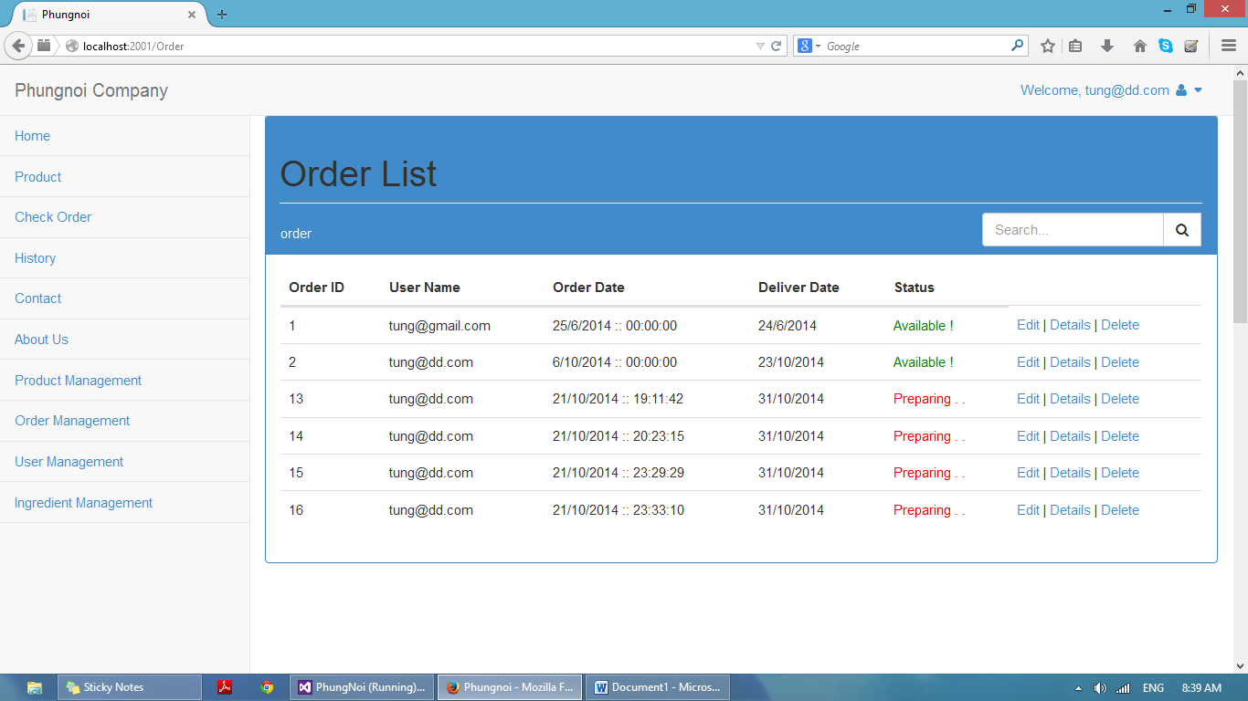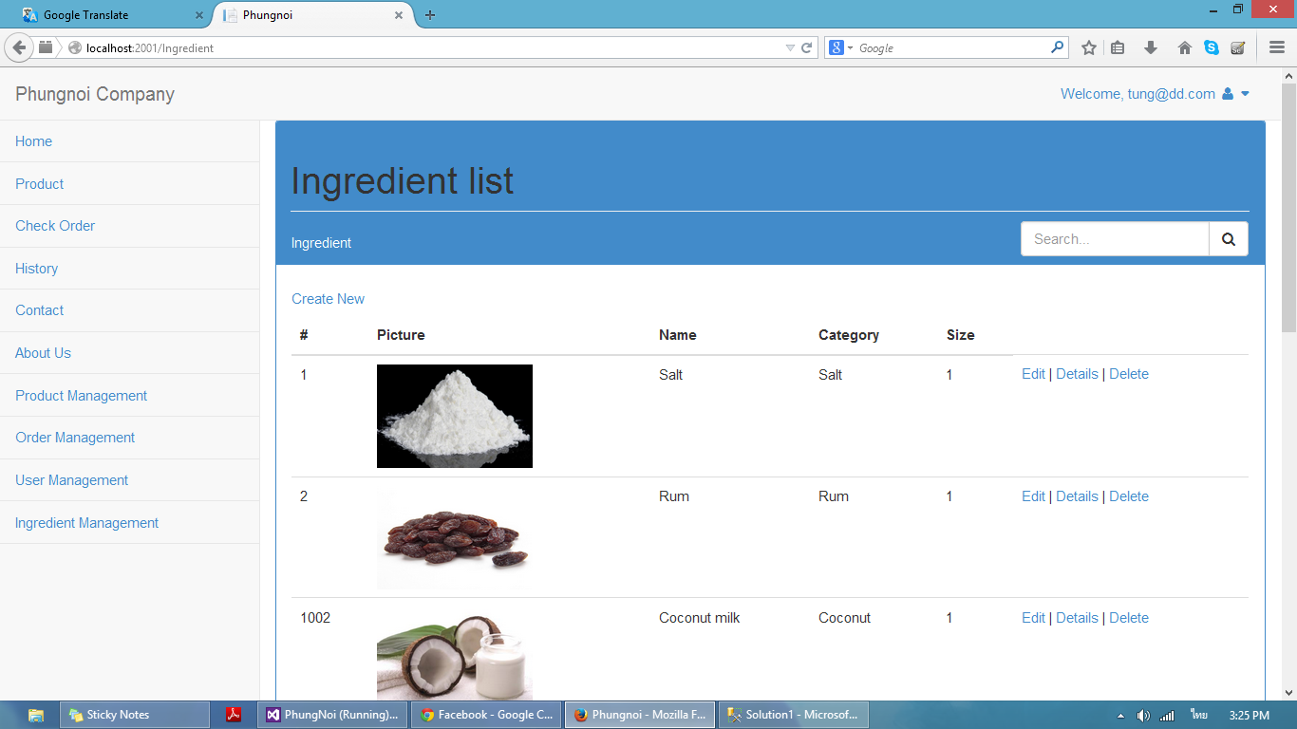

**Team Member Picture**



Nontra Mahachanont 542115026



Parinya Panyanak 542115034